THE UNIVERSITY OF AZAD JAMMU & KASHMIR
DEPARTMENT OF SOFTWARE ENGINEERING

Student Name | Syed Muhammad Hassan Gillani | 
Roll Number | 2024-SE-42
Course Name | Software Construction & Development
Course Code | SE-3101
Session | 2024-2028 (BS SE - 5th Sem)
Department Name | Department of Software Engineering
Task / Assignment No. | Lab Task #01
Instructor Name | Engr. Dr Asma Javed
Submission Date | October 25, 2026
Topic / Title | UML Use Case Diagram

LAB EXPLANATION: UML USE CASE DIAGRAMS
1. Introduction to UML Use Case Diagrams
A Use Case Diagram is a behavioral UML diagram used to represent the dynamic aspects of a system. It defines system boundaries, external entities (Actors), and functional requirements (Use Cases) to clearly outline what the system does without getting into implementation details.

2. Question 1: Online Ticket Reservation System
2.1 Identified Actors
Actor Name | Actor Type | Role & Description
Customer / Passenger | Primary Actor | Initiates search, selects seats, completes ticket bookings, and downloads e-tickets.
System Administrator | Secondary Actor | Manages schedules, updates routes/fare prices, and monitors system reports.
Payment Gateway | External System Actor | Authorizes payments, processes bank transactions, and returns authorization status.

2.2 Use Cases & Diagram Workflow Explanation
- Search Tickets / Routes: Customer queries available trips based on origin, destination, and travel date.
- Select Seat: Customer views interactive seat layout and chooses available seats.
- Book Ticket: Core use case executed by Customer. Automatically triggers <<include>> dependencies for 'View Available Seats', 'Process Payment', and 'Generate Booking Confirmation'.
- Cancel Reservation: Customer requests booking cancellation and initiates refund processing.
- Download E-Ticket: Allows customer to retrieve and print finalized e-ticket after payment verification.
- Manage Routes & Schedules: Admin configures available trips, bus/train routes, and pricing.
- Generate Reports: Admin extracts booking and revenue statistics.

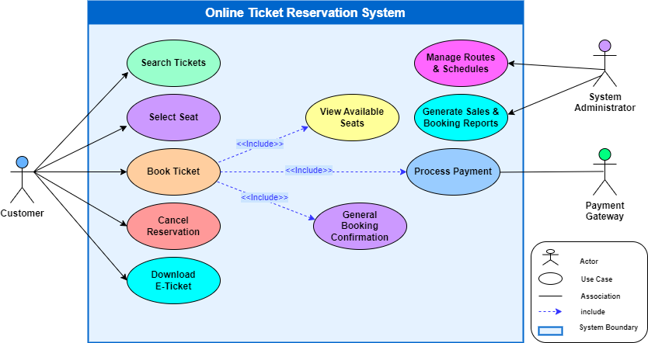

3. Question 2: Credit Card Processing System Case Study
3.1 Identified Actors
Actor Name | Actor Type | Role & Description
Customer | Primary Actor | Selects items, provides payment card, and signs printed transaction receipt.
Vendor | Secondary Actor | Generates bill/invoice, handles payment terminal interaction, and hands receipt to customer.
Credit Card Machine (POS) | System / Hardware Actor | Processes amount transaction, verifies balance limits, and prints receipt/statement.

3.2 Case Study Step-by-Step Mapping & UML Stereotypes
- Step 1 (Select Item): Customer selects items from shop. Connected via <<extend>> to Process Transaction.
- Step 2 (Make Bill): Vendor creates bill for items. Associated directly with Credit Card Machine.
- Step 3 (Swipe Card): Customer hands card to vendor. Triggers <<include>> relationship to 'Process Transaction'.
- Step 4 (Process Transaction): Credit Card Machine processes transaction amount and checks card balance limit.
- Step 5 (Print Statement / Receipt): Machine prints receipt statement. Includes <<include>> link to 'Print Receipt'.
- Step 6 (Sign Receipt): Customer signs physical receipt and returns to vendor. Stereotyped as <<extend>> to 'Print Statement'.
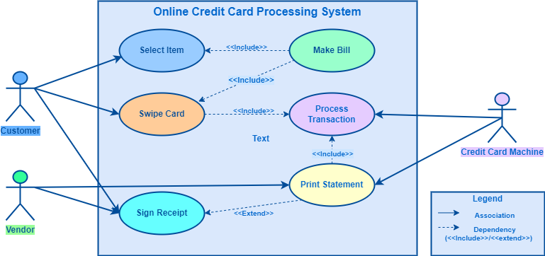
4. Summary of Key UML Stereotypes Used
• <<include>>: Represents mandatory sub-routines. For example, swiping a card mandatory triggers transaction processing.
• <<extend>>: Represents optional or conditional execution steps. For example, signing a receipt happens after receipt printing is completed.
• System Boundary: Encloses all use cases, separating internal functional capabilities from external actors.

